A Circular Queue is a special version of queue where the last element of the queue is connected to the first element of the queue forming a circle.

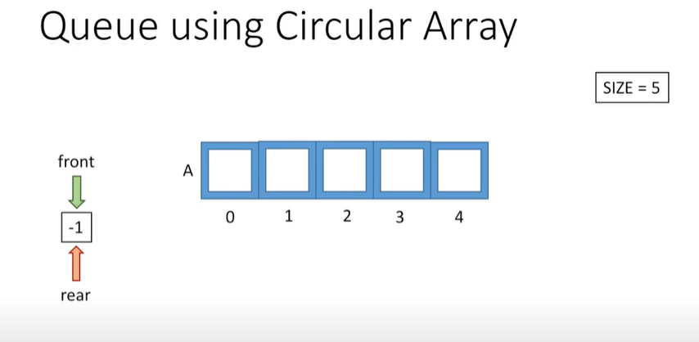

See initially both front and rear will be at -1 .rear at end where element inserted and front from where element removed.

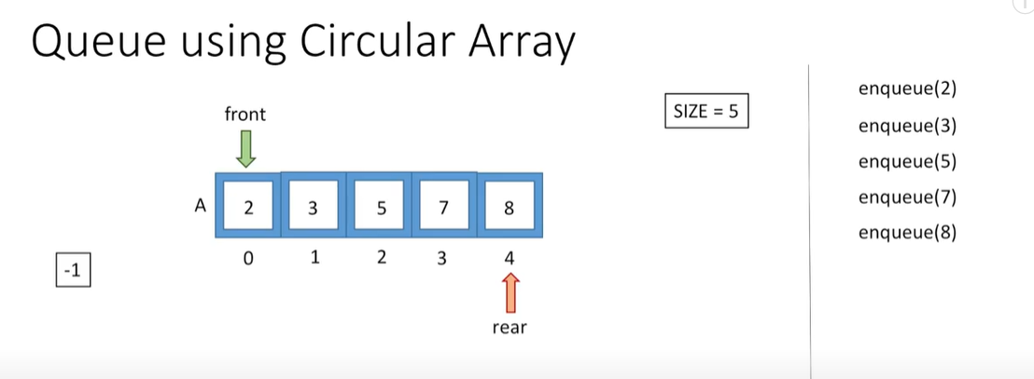

See when first element inserted the front=rear=0 and insert element. see the position of rear and front after array is full.

See after deque we will front ++ position and not consider 2 as part of queue.

See now we do dequeue and then enqueue we cannot insert as rear is at end of array.

See by using that circular array to insert at index 0 and 1 using %size.

See here 1 issue to see if queue full is rear==front.

See now we cant insert 11 as rear+1==front.

Code:

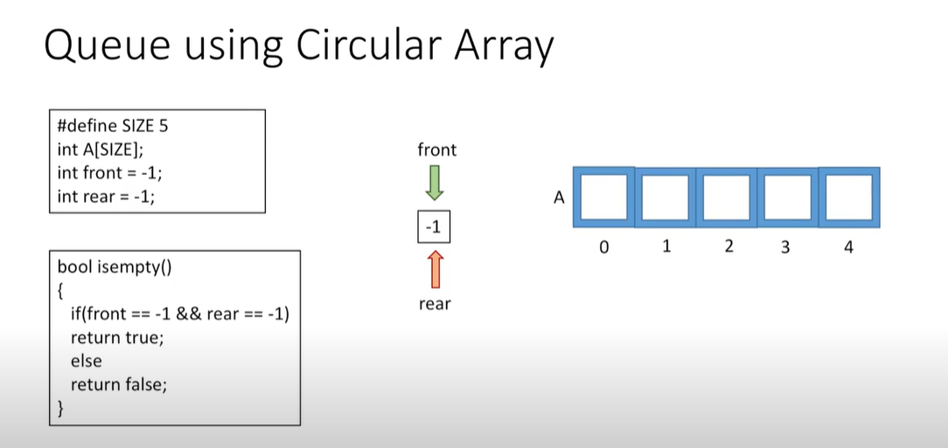

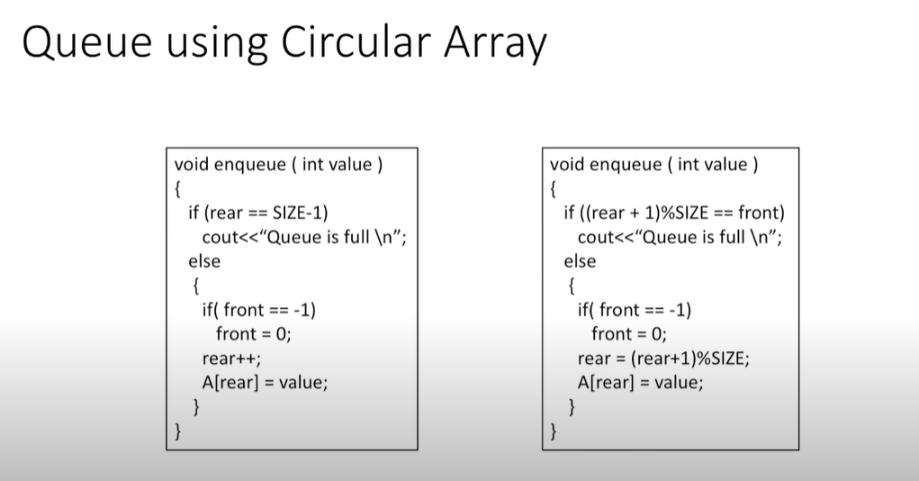

Left is normal queue and right is circular queue.

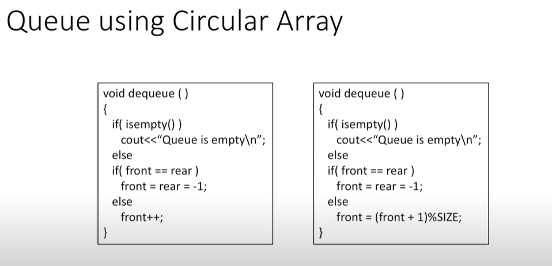

Left is normal queue and right is circular.

